Problem Scenario: hi

Loudacre Inc. is a leading electronics retailer
– More than 1,000 brick and mortar stores
– Dualcore also has a thriving e-commerce Web site

Loudacre has hired you to help find value in its data
– You will process and analyse data from internal and external sources
– Identify opportunities to increase revenue
– Find new ways to reduce costs
– Help other departments achieve their goals

Ques 1: List all the databases in the RDBMS
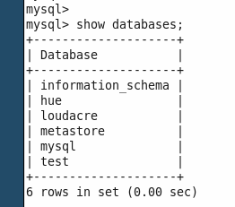

Ques 2: Make a directory on HDFS named as /Loudacre

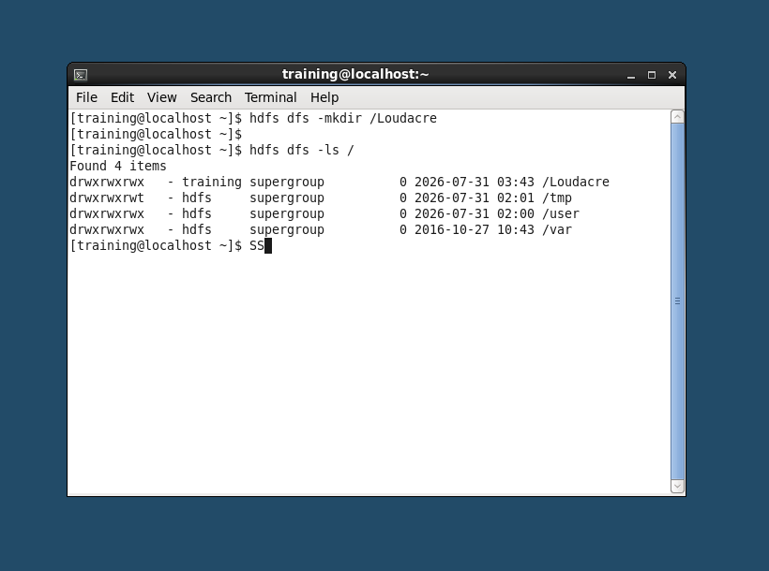

Ques 3: Import accounts, accountdevice, webpage into the directory /Loudacre separately
sqoop import --connect jdbc:mysql://localhost/loudacre --username training --password training --table accounts --target-dir /Loudacre/accounts
Ques 4: Import table accounts in /user/training changing the mappers to 10 and changing the field terminator to ‘:’. Also split them on the basis of state.

sqoop import --connect jdbc:mysql://localhost/loudacre --username training --password training --table accounts --target-dir /user/training/accounts -m 10 --fields-terminated-by ':' --split-by state

Ques 5: Import the Complete names of people having accounts in Loudacre
ex: firstname <space> last_name
ex: Britney Spears

sqoop import --connect jdbc:mysql://localhost/loudacre --username training --password training --table accounts --columns "first_name,last_name" --fields-terminated-by ' ' --target-dir /Loudacre/complete_names

Ques 6: Import only those records where device_id is between 10 and 50 in table accountdevice.

sqoop import --connect jdbc:mysql://localhost/loudacre --username training --password training --table accountdevice --where "device_id BETWEEN 10 AND 50" --target-dir /Loudacre/accountdevice_q6

Ques 7: Copy the acct no.from the table customerservicerep where customer name is Roger Miller.

sqoop import --connect jdbc:mysql://localhost/loudacre --username training --password training --table customerservicerep --columns "acct_num" --where "cs_name='Roger Miller'" --target-dir /Loudacre/roger_acct -m 1

